How to connect to the remote linux server?
ssh client
putty/ MobaXterm/ git bash-> windows user
ip address:
username: ubuntu
password: .pem file (devops.pem)
ssh -i devops.pem ubuntu@<ip>
Version:
Helps to track the changes we are making to a software over the period of time.
Significance of digits in version e.g. IOS 13.5.1
13-major (n number of features added, improve performance)
- minor (bundle number of defects and simple use case)
- HotFix (minor bug fixes)
Version Control System (VCS)/Source Code Management (SCM) is a tool that helps to track the changes happening to file in your source code- GIT
Types of version control tools
- local vcs- SCCS Source Code Control System
- centralized vcs- (svn/ tfs/cvs)
- distributed vcs- (git/mercury)
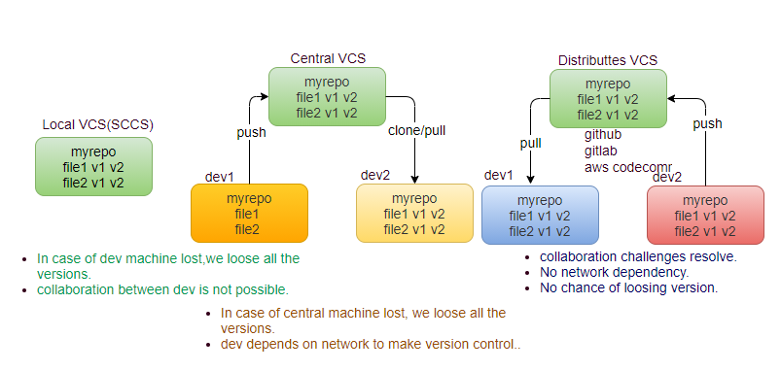
make change (CRUD?)
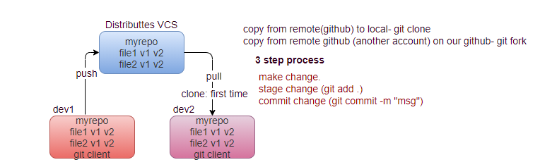

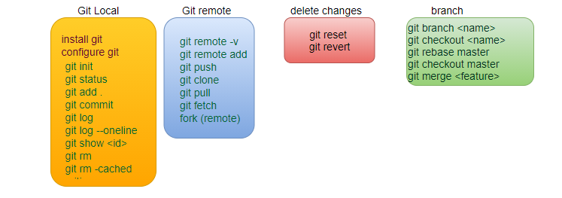
Google Cloud
Create VM instance (Ubuntu 18.04)
Step1: Install git client and configure
git config --global user.name neeraj // in tracking will show the details changes done by whom
git config --global user. email neerajvohra7419@gmail.com
git config –list

Step2: initialize local repository, any changes in this directory tracked by Git.
mkdir myproject
cd myproject
git init
#Hey! git track the changes (CRUD) in particular directory (creates local repo. git)
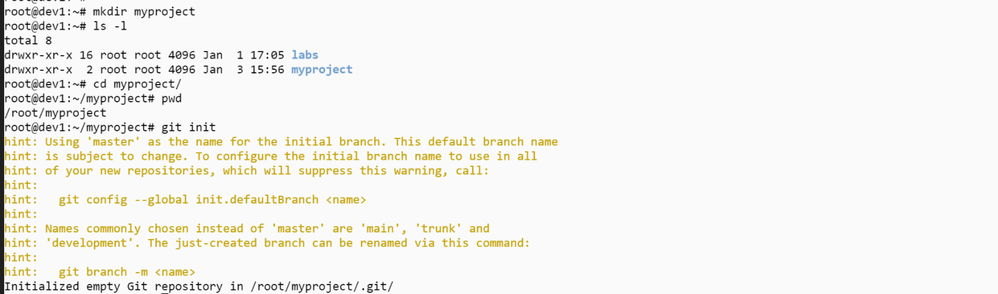

make changes (create/update/delete any file)

Work area- any change (red color not tracked by git)
Staging area- git get access (green color), git start track changes, Identify the changes.
Commit area: Git Says I know all the changes, creates a version history
- local repository (creating a version history)
git status
every commit creates a new version id, HEAD represents the latest version id.

How to check commit area?
git log --help
git log
# Shows all the commit id (version tracking system) HEAD refers to the recent commit id
git log --oneline #only commit id
git commit -am “message”
# add and commit in one command -a (all can’t specify specific file)
git log <commit Id> # who did the commit (version history)
What change did in particular commit id?
git show <commit Id>
How to avoid some files for tracking in my repository?
touch. gitignore #. <file> as a hidden file
nano .gitignore
neeraj.info // file
*.log // wild character
test/ //folder
cat .gitignore

How to see hidden files (.) in directory?
ls -al
All files inside .gitignore will be ignored (not tracked by git), .gitIgnore file specific to project but not to specific user.

Can we un-track the already committed file?
No, because git is already tracking it.

How can we refer each commit as a version number instead of commit id (alias name for long commit id?)
Tagging:
Every commitid refer to a new version, Tag refer to the release number.
git tag -a “v1.5” -m “version 1.5” // alias name for long commit id
git tag -a // took the recent commit id always
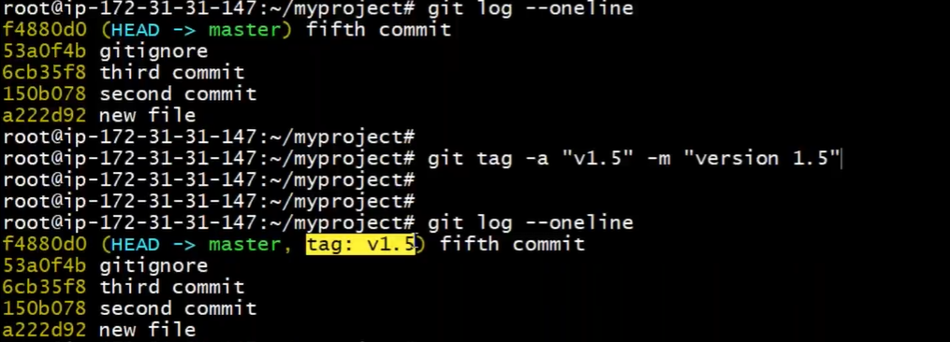
By default it takes a latest commit id to tag the version number.
How to tag specific commit id with version no?
git tag -a “v1.0” <commit Id> -m “version 1.0” // alias
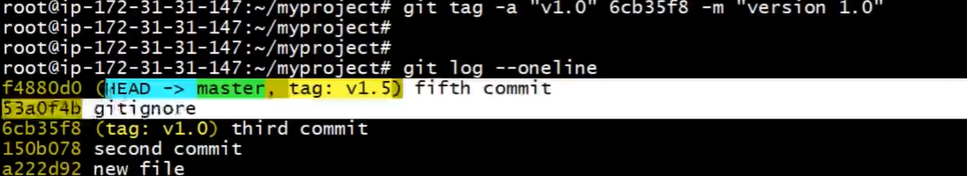
Now user can easily know that code till commit id 53a0f4b corresponds to version 1.0.
Can we automate the tagging?
No first we have to commit, we tag only commit id, not the file.

How to see differences between two versions?
git diff v1.5 v1.0

REMOTE REPOSITORY
step1: create a repository in a remote
git remote add origin < remote repository path> # where to upload the changes.
git remote -v
# (local repository doesn’t know where have to upload the changes)
git push -u origin master # -u upstream origin-> remote URL
As of now we have uploaded everything from our local system to local git repo. Whatever committed will be push on to the remote repository.
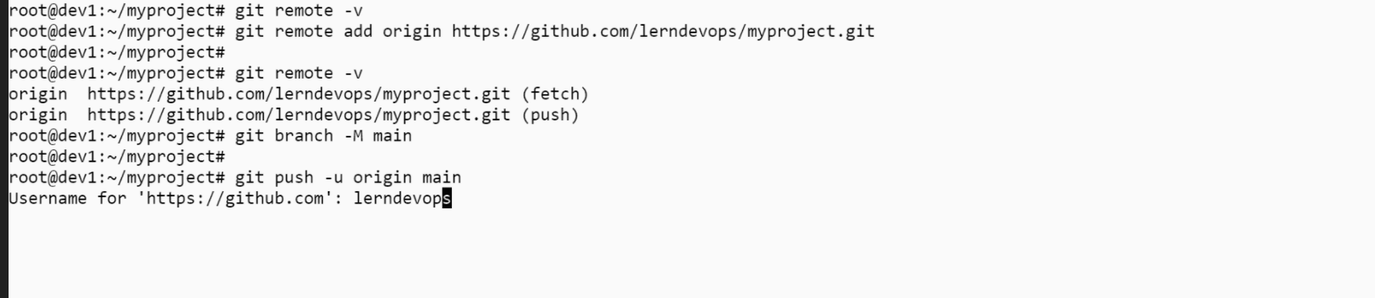
git branch –M main # create a main branch from default master
git push -u origin main # u upstream, origin remote repository URL
UC: Consider that a new developer joined our team, he also has to install git client, and firstly he will make a local copy from the remote (entire project’s copy).
git clone - first time operation, along with all commit id (versions).
git log // all the versions (commit id)
git add dev2.java
git commit -m “dev2 changes”
git log # header incremented in Dev2 Machine.

dev2 push his/her changes to Github, changes are pushed along with commit id.

UC: Now developer2 have done some changes and pushed to remote, develper1 wants to add only those changes in his local repository, not the whole repository?
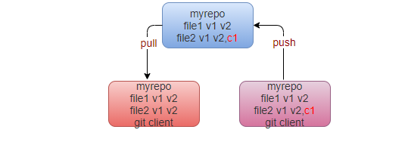

git pull
# We taking the changes from remote repository and adding it into local repository (also merging), also update the HEAD.
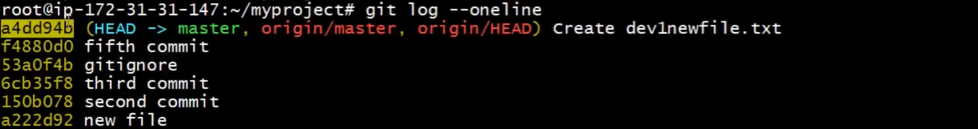
UC: Dev1 did some changes in 1.java file and pushed it on the remote.
Dev2 don’t want to take latest changes by dev1, but wants to know is there any changes in the remote which are not available in his local?
git fetch
doesn’t update the local repository, just tell that there is some change in remote if any.
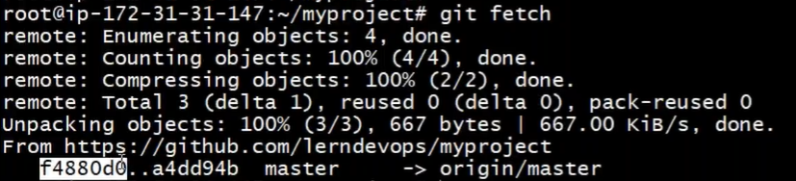
fetch just tell there are change in your local HEAD (master) and remote HEAD (origin/master), git fetch doesn’t get the changes and add into your local just tell that there is something new in remote repository.

UC2: dev1 has pushed some change on the remote, dev2 trying to push his/her changes (without taking the latest pull from remote)
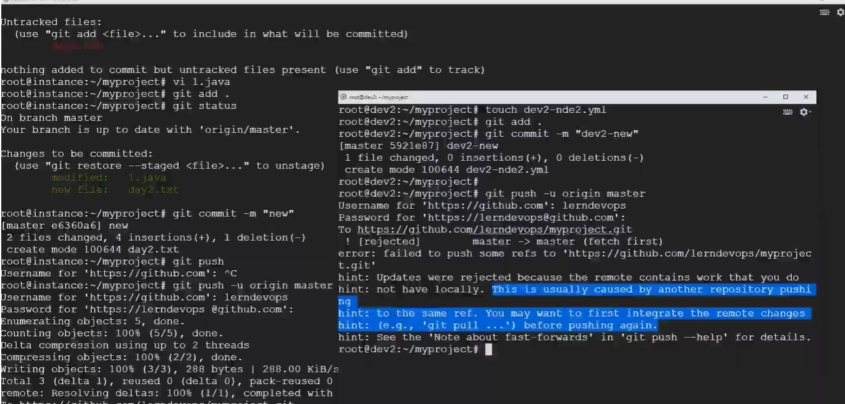

UC3: Both dev did changes in same file, dev1 has pushed the changes in remote.
Now dev2, first pull the latest code (else conflict will be happen during push by dev2 because changed file already pushed by dev1)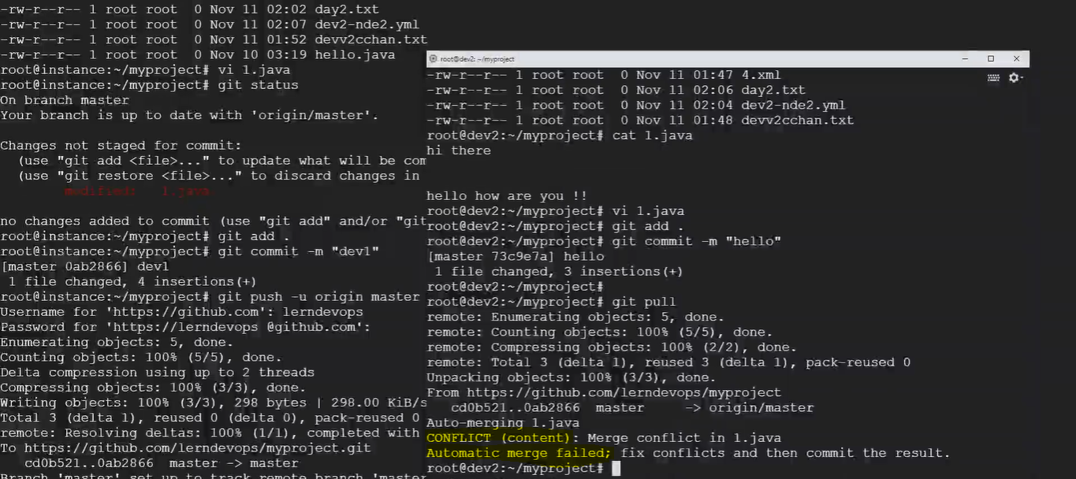nano 1.java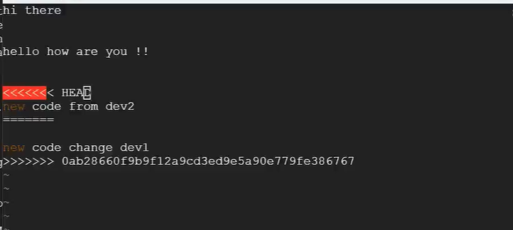
both dev has to sit together and clean the file.
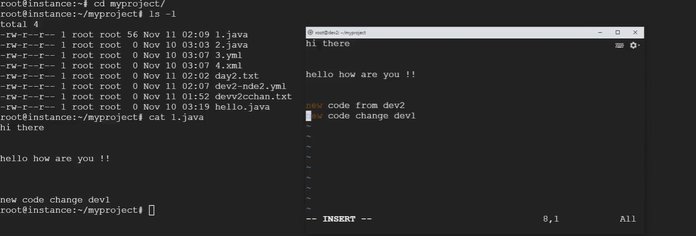
Once file is clean, dev2 to add., commit and push the file to remote, and dev1 will pull the file from remote.

Fork:
To contributes towards the open source code.
Fork the project of open-source project (different branch), copy it make the changes, upload in your own repository, create a pull request (you don’t have access) to remote party.
remote party will receive a pull request, after receiving the pull request remote party can merge/deny the code in its own repository. clone is for local (owner), fork is for remote account (don’t have write access).
There is an operation on remote repository
Fork, it will make a copy from remote account to our account. Fork is operation to make copy of public resource in your account (clone).
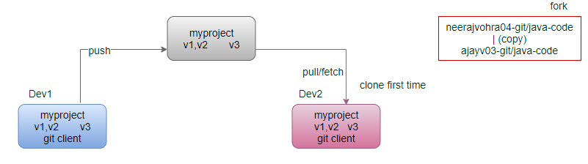
step1: Login into your account.
step2: Go to open-source link (third party publically access repository)
step3: Click on fork (will copy the remote repo in your git hub account)
step4: contribute to open source by cloning and adding some new utilities, and commit the same in your local repo.
step5: push the changes in your git hub account.
step6: raise a pull request to third party (owning the open-source code), can’t directly upload the change only can request from owner of the repository.
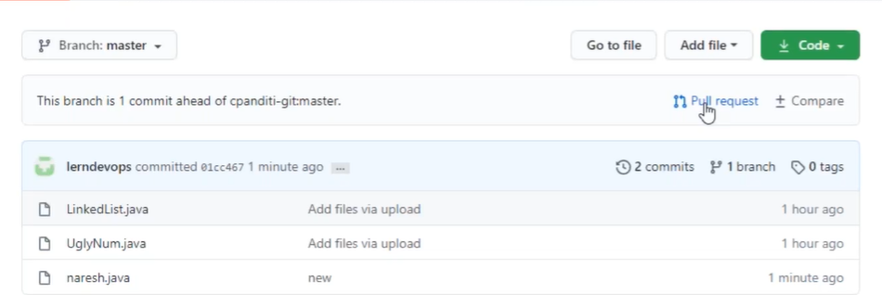
It’s the way to contributing to open source.
step7: A new pull request available to the third-party account which either can be accepted by merging or rejected by the third party.

Rolling back the changes.
touch abc.txt
git add . // work area ->stage area
git commit -m “rollback” // stage area -> commit area
git status
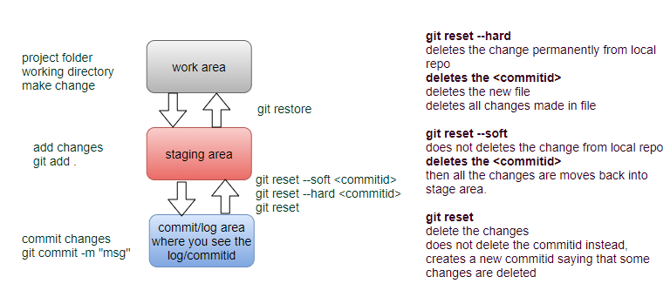
UC: revert the change: we want to delete the commit id and revert back to staging area from commit area. (Before pushing to remote)
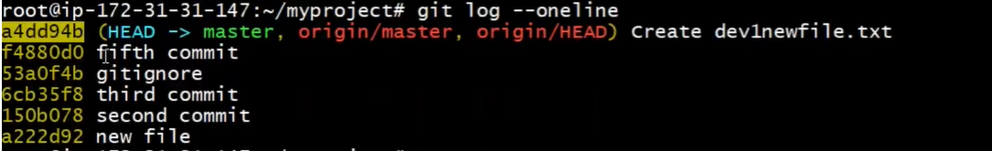
We want to revert back the commit id a4dd94b
touch new
git add .
git commit –m “add new file”
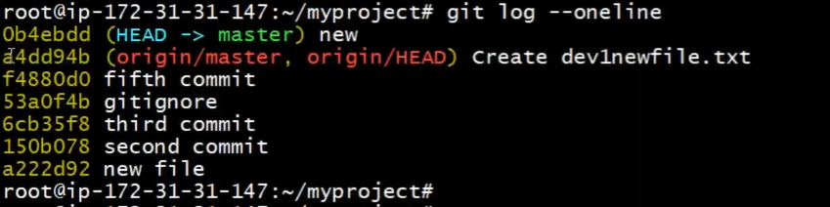
git reset --soft <commit Id> #commit id where we want to reach.
git reset --soft a4dd94b # commit area to staging area
git status
UC: revert the change: we want to revert back to work area from staging area
git restore --staged <file name>
git restore --staged abc.txt
git status
UC: Now delete from work area
rm abc.txt
ls-l
UC: how can we delete from all area in one shot?
touch abc.html new.yml
git status
git add .
git status
git commit –m “hard reset”
git status
git log --oneline
git reset --hard <commit Id>
# Will be delete from everywhere including commit id (delete from the repository)

What is git stash command?
UC: fileA is in staging area we haven’t committed yet, meanwhile we have received a blocker defect, which we have to deliver on priority. In this case we have to commit the defect code on priority, and also to ensure that fileA code neither to be committed, nor to be restore back to working area.
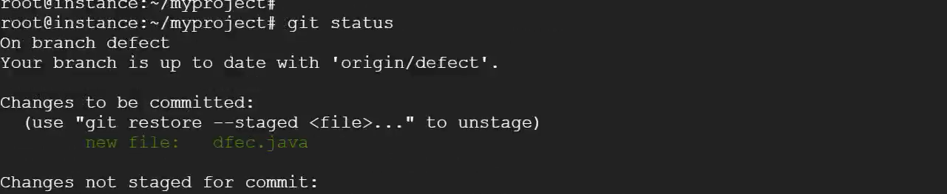
git stash: will move all the stage files in special area called stash, will not be candidate for commit.
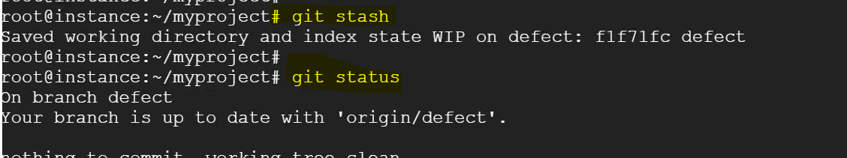

UC: If we want only newfile move to stash area
git stash newfile
git commit -m “production defect code”
Now commit command will only commit the defect.java
git log --oneline
git push

UC: How newfile will be back from stash area in future, after delivering the defect code?
git stash list
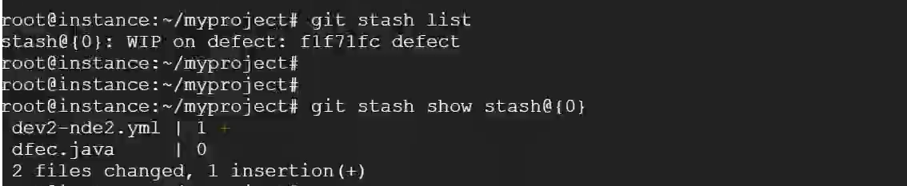
git stash show <stash@{0}> # f.txt available
git stash apply <stash@{0}> # back again into staging area
git status # feature file available again in staging area

Branching: Why do we need branching (by developers)?
UC: Team have pushed our code in GitHub, v1is successfully deployed on the production
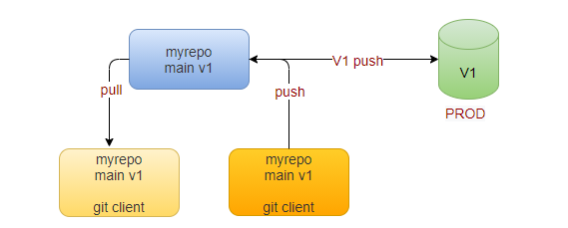
Once code is delivered, team has started work on new feature feaxy, meanwhile client reports a defect on v1 code, and now team has to work on both new feature as well as defect.
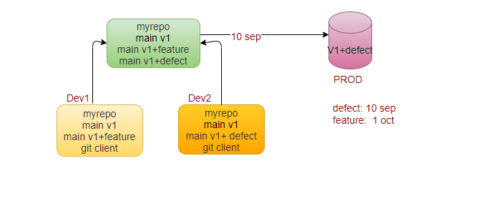

Problem: in git hub main branch we have code of defect as well as of feature, how will move the only code written for defect (v1+ defect code) on the production on 10th Sep?

Solution: Branching, makes your release smooth. Instead of working on the main branch (original code), each developer work on their own copy of the main branch, it is always a copy of the original (main branch).

The developer 1 has featxy branch (copy of main branch) and developer 2 has defect branch (copy of main branch), and both start working on their separate branch.

The developer 1 push his code on remote and developer 2 push his code on the remote. Now in master we have three copies (versions of the code).Three copies of the code.

Our objective to deploy only 1 version (defect v1 + d1)

UC: First create a branch in Remote by admin and team member clone the specific branch in their local.

Clone of specific branch
git clone -b featxy <URL>

Strategy: merge the defect copy version with master copy version and deploy, always deploy master version.

mkdir myproject
cd myproject
git init
# By default, whenever we initialize the git will get the master branch is the default branch
can be change to main branch
git branch -M main # will change the master branch to main branch
git status # on branch master/main
touch 1.java 2.java
git add .
git commit -m “m1” # m1 master branch
touch 3.java 4.java
git add .
git commit -m “m2” # m2 master branch
git branch # existing branches with current branch*
git log --oneline # 2 commits corresponding to v1
git push -u origin master/main

git branch feature # will create a copy of the branch from where it executed
git branch # have two branches (copies) master and feature
git checkout feature # switch to feature branch
git branch
git ls -l # same as master
git log --oneline #same as master branch(copy)

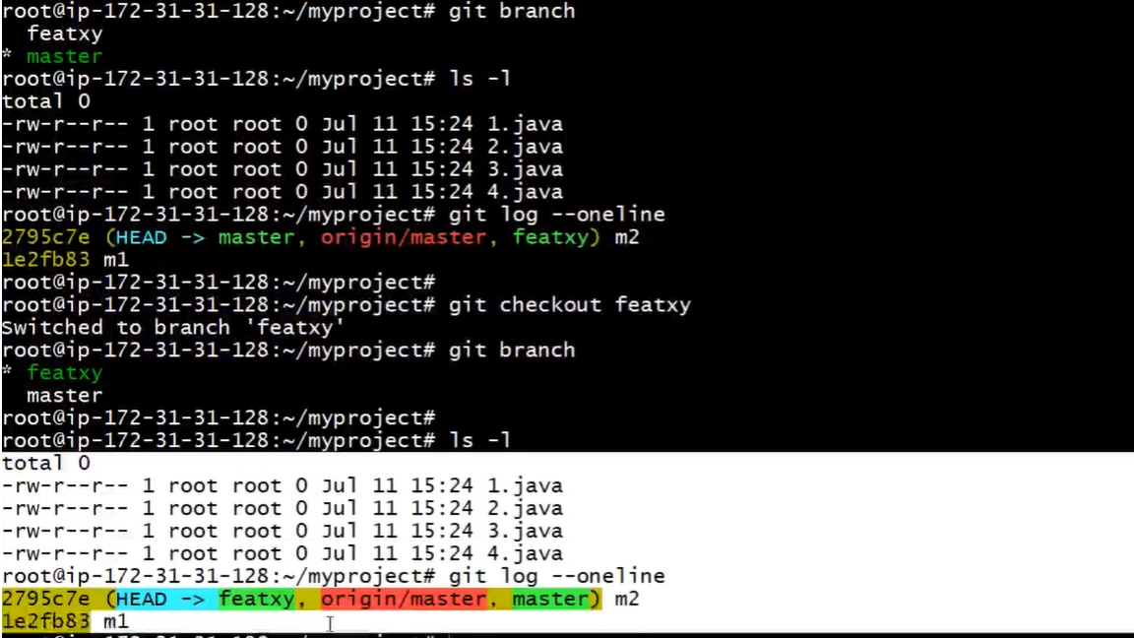
any changes done in any branch will not be reflected in any other branch.
touch f1.java
git add .
git commit -m “f1 in feature branch”
touch f2.java
git add .
git commit -m “f2 in feature branch”
will not reflect in master branch (locally or remotely)
git log --oneline // HEAD is moved to f2
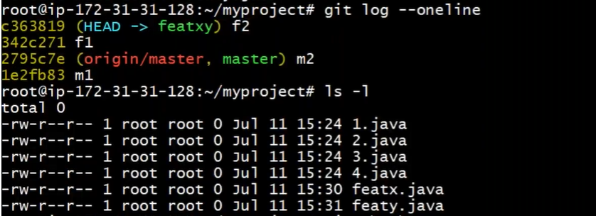
git checkout master #switching to master
ls -l # same as previous no change in master branch
git log --oneline #same as previous no change in master branch
We have two distinct copy (version) available on my local.
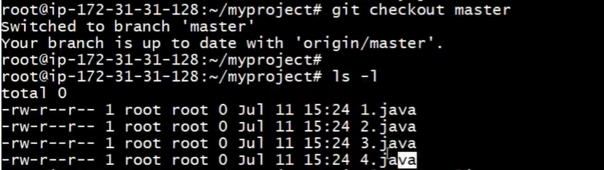
git push -u origin feature #feature branch will be uploaded
Now in remote we have 2 copies, we can directly release this feature branch in production if we want.

UC: we want to deploy master/main branch, in production always deploy the master/main branch, how to push the changes in to master branch?

We can do the same either in remote or on local, generally merging happen at remote location.
Consider the scenario on the remote, in remote have option of pull request.
In local there is no concept of pull /merge request.

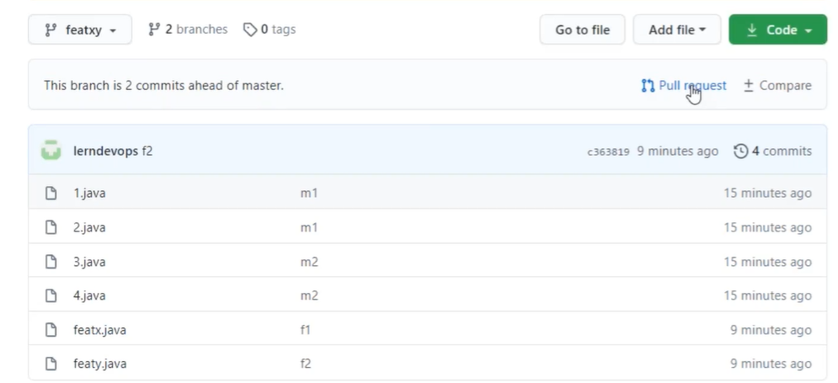
You don’t have access to the master/main branch. In that case you need request to the member who have access to the master/main branch, request done through the pull request (request to the owner of the master/main branch, saying that I have done some changes, you can review it and can add into the master).
When you create a pull request it goes into the pull request page of the owners of the master/main branch.
Owner will reviewer the changes once he submit the review request, will get the option of merge the request on clicking the merge pull request get option of confirm merge request as owner confirms the merge request feature code merge with master branch. Owner also can return back the request with some suggestion. Once you send a pull request your branch becomes locked and will be unlocked once your request will be accepted or returned back. You can also close pull request.
Once you finalize your changes only then create a pull request.
How to merge in local? No approval concept
scenerio1:
master: m1 m2
feature: m1 m2 f1 f2
git checkout master # switch to master branch
git merge feature
master: m1 m2 f1 f2
scenerio2
master: m1 m2
feature: m1 m2 f1 f2 will be release on Oct-1st by Dev1
defect m1 m2 d1 d2 will be released on 10th Sep by Dev2

On 10th Sep
master: m1 m2 d1 d2
feature: m1 m2 f1 f2 will be release on Oct-1st by Dev1
On 1st Oct
git checkout master
git merge feature
What will be the master, because there is something extra d1, d2 in master which is not available in feature branch, there are lots of options, but for clean history option1 is correct?
master: m1 m2 d1 d2 f1 f2
m1 m2 f1 f2 d1 d2
m1 m2 d1 d2 f1 f2 e1
m1 m2 f1 f2 d1 d2 e1
# There is issue in this order if someone see the history
e1 commit id is useless because it doesn’t refer to any change in source code, git automatically generates an unnecessary commit Id against any merge request, order of history is misleading.
Best Practice
When you create a feature branch from master branch (m1 m2), and when you are merging back your feature branch (m1 m2 f1 f2) with the master branch (from where you have creates a branch), you have to ensure always merge with the latest version of the master branch (or because as per our above scenario, it may be possible that after creating a feature branch from the master branch some other developer has already pushed the changes on the master branch (defect branch), means the currently master version (m1,m2,d1,d2) is not same as at the time of you have created your branch (m1,m2).
Means before merging first pull the latest code and after that merge your code in that code.
base of the feature branch is the HEAD of the master from where branch is created, by default merge always merged the code on base of the feature branch’s HEAD.

Before the merging ensure that base of my feature branch is always the latest of the master branch.

On 10th Sep
master: m1 m2 d1 d2
feature: m1 m2 f1 f2 will be release on Oct-1st by Dev1
On 1st Oct
git checkout master
git merge feature m1 m2 f1 f2 d1 d2 e1
# There is issue in this order if someone see the history

Solution: Rebase
On 1st Oct
master: m1 m2 d1 d2
feature: m1 m2 f1 f2
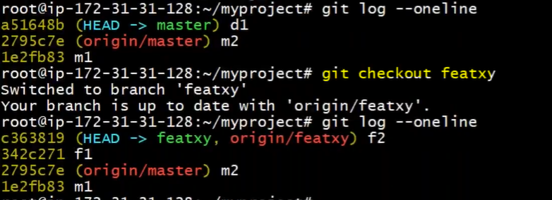
git checkout feature # switch to feature branch
git log --oneline
m1 m2 f1 f2
Before your current branch (feature) merge back to the same branch (master), first take a current latest from same branch (master), and rebase your current branch (feature) with master.
git rebase master # you have cleaner history local->local in feature branch
git log --oneline
m1 m2 d1 d2 f1 f2
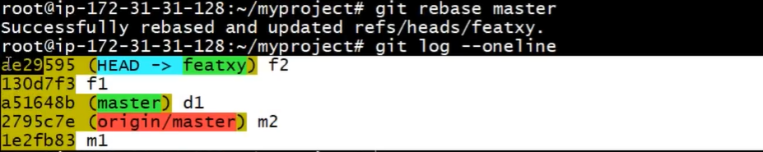
git checkout master # switch to master branch
git merge feature
git log --oneline
m1 m2 d1 d2 f1 f2
rebase ensures the clean history, hence before merging any feature branch in master first rebase the feature branch with master will ensure that will maintain the clean history.

How to delete the branch
git checkout master
git branch
git branch -D feature
If will try to delete master branch from within master branch will not deleted
We can also delete the feature branch from the remote.

Merge Conflicts
git branch # master
git branch defect # create a new branch defect
git branch # master, defect
master/main | Defect
1.java | 1.java
2.java | 2.java
3.defect.java | 3.defect.java
4.featx.java | 4.featx.java
modify defect.java | modify defect.java
git add . | git add .
git commit -m “conflict” | git commit -m “conflict”

UC: You are working on defect.java file in defect branch and at same time some other developer has also updated the same defect.java file in master branch. Or it may be scenario that both are working on different features but working in the same file. It must be the same file.

git checkout defect
nano defect.java
git add .
git commit -m “change in defect branch-conflict”
git checkout master
nano defect.java
git add .
git commit -m “change in master branch-conflict”
We have modified the same file in both branches. Merging is always getting the changes from one branch to other branch.
git checkout master
git merge defect #automatic merge failed, except the file have conflict remaining will merged
How to solve?
step1: Open the file have merge conflict (defect.java)
nano defect.java
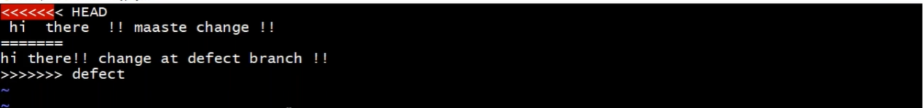

git status
git add .
git commit -m “resolve merge conflict”

Git workflow
